Summary of NEDDC Local Plan Issues and Options Consultation on the Strategic Approach to the Location of Development and Refined Sites (March 2026)

Introduction

- Thank you for consulting Bolsover District Council on your Local Plan Issues and Options Consultation on the Strategic Approach to the Location of Development and Refined Sites (March 2026)’.

- It is noted that this consultation stage is additional to that set out in the NED Local Development Scheme and that its purpose is to consult upon:

- the Strategic Approach to the Location of Development, that is, those matters that determine the direction of the Local Plan and set the context for more detailed policies and site allocations; and
- a refined schedule of sites that have passed through both the initial desk top screening, and further detailed stages of assessment; and which align with the emerging strategy approach.

- As a result, Bolsover District Council wishes to make comments about the following matters:

- Strategic Approach to the Location of Development and Green Belt Review
- Strategic Site / New Settlement selection process and justification
- Approach to employment land
- Potential Development along the A632 Corridor
- Potential Development along the A6135 Corridor
- Potential Development at Holmewood

A. Strategic Approach to the Location of Development and Green Belt Review

- We note that the strategic approach to the location of development is proposed to be guided by the priority locations set out in the Settlement Role and Function Study evidence (as shown in the table below). It is noted that as a result higher levels of development would be directed to the higher priority and thus more sustainable locations and then cascade down.

Priority Level | Location Types
Priority 1 Locations: | - Edges of Chesterfield/ Sheffield  - New Settlement /Strategic Sites  - Level 1 Settlements - Main Towns
Priority 2 Locations: | - Level 2 Settlements - Larger Villages
Priority 3 Locations: | - Level 3 Settlements - Smaller Villages
Priority 4 Locations: | - Level 4 Settlements – Very Small Villages / Hamlets

- Related to this strategic approach to the location of development, we note that a large amount of North East Derbyshire District is within the North Derbyshire Green Belt and that this affects a number of the higher priority level areas.

- To this end, we note that NEDDC are carrying out a Green Belt Review and that this evidence is not yet available but expected in the summer. As such, it is noted that this evidence will influence choices about how much growth can be directed to sites within Priority 1 locations and how much growth needs to be directed to lesser priority and thus less sustainable locations.

B. Strategic Site / New Settlement selection process and justification

- It is noted that one strategic site option shown within the consultation documents is a new settlement at Duckmanton where 2,000-3,000 homes could be potentially accommodated.

- Whilst New Settlements / Strategic Sites are identified as Priority 1 locations, we note that that this site adjoins two Priority 3 Settlements, namely Arkwright and Duckmanton, and therefore we would raise concerns about the sustainability of this location for development.

- We note the Sustainability Appraisal (SA) process has considered potential location types for new growth and that the SA of the NED Local Plan: Issues and Options report (June 2025) showed that for this new settlements and strategic sites generally performed better than larger and smaller villages. The SA of the NED Local Plan: Addendum to the Issues and Options (March 2026) assessed the impacts of the 4 strategic site options and concluded that the Duckmanton Moor Site (45227) was the best performing against the SA objectives. The other site at Duckmanton (45541) was the joint next best performing site with Land south of Clay Cross, with Land south of Eckington being the worst performing strategic site out of the four.

- However, at this stage we note that important evidence, such as an updated Infrastructure Study and Delivery Plan that would demonstrate how the impacts of the potential strategic sites upon local infrastructure, including that close by in Bolsover District in the case of the potential Duckmanton new settlement / strategic site, is not yet available to help the District Council understand how the impacts of growth in these locations can be sustainably accommodated.

- Therefore, it would be helpful if a Strategic Sites Topic Paper could be produced that charts out why strategic sites are necessary, how their impact on local infrastructure can be accommodated and why growing larger higher order settlements is not a more sustainable option.

C. Approach to employment land

- It is noted the consultation feedback that shows that 80% of respondents wanted an employment target at the lower end of the range 15 – 31 ha. However, there appears to be no indication within the published documents about what NEDDC’s options are for an employment land target based on the recent Economic Needs Assessment 2025 or whether the setting of an employment land target would be affected by the expected higher housing target 12,000 dwellings over the plan period. Further, there is no discussion within the documents about NEDDC’s approach to the provision of logistics sites within their plan area.

- On a wider note, it is currently unclear whether employment land will be distributed in accordance with the strategic approach to the location of development.

- Related to this, we note under Level 3 settlements – Smaller Villages – Land south of Markham Vale, Long Duckmanton (45041 - shown in the image below) is identified as a 41 ha site that could provide opportunities to meet the needs of the sub-regional / regional logistics sector.

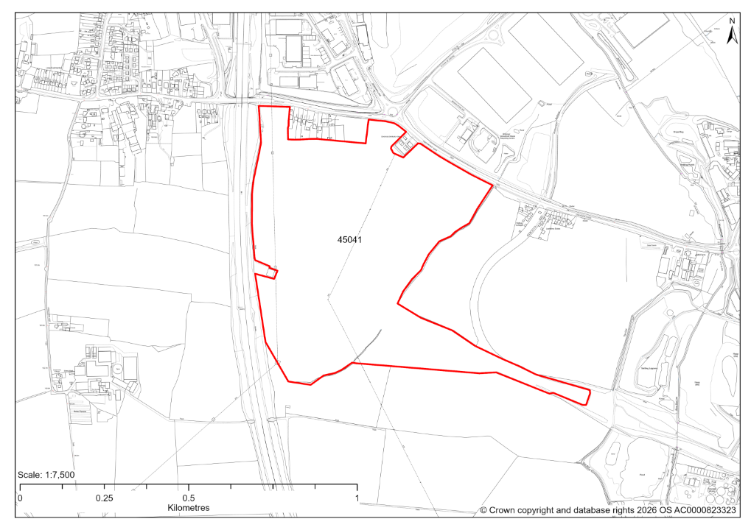

- We also note that there is a smaller scale potential employment site at Doe Lea that sits within the parish of Heath (shown below). This site would appear to form an extension to Doe Lea, rather than be located to any settlement in North East Derbyshire District and its impact on Doe Lea needs further assessment.

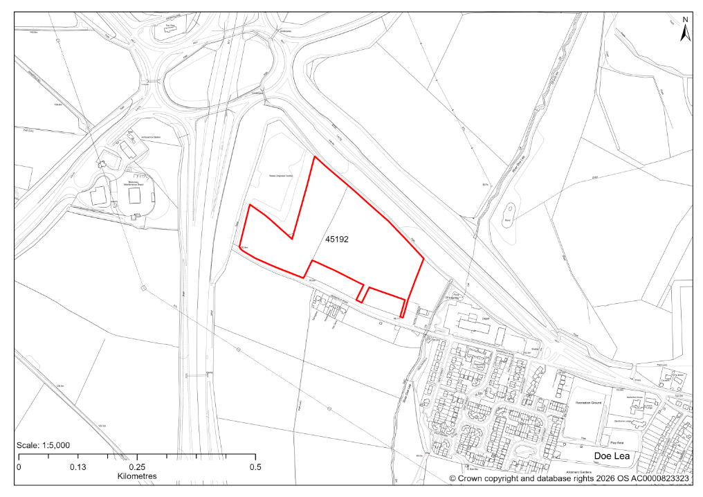

- As a result, Bolsover District Council would expect to see more discussion about NEDDC’s approach to employment land, both general and sub-regional logistics, and see a strategy that considers the following points:

  - Plan for sites near motorway junctions?
  - Plan for sites near the most sustainable settlements?
  - Plan for sites that increase job opportunities in settlements that have fewer current job opportunities?
  - Plan based on the land that is being made available?

D. Potential development along the A632 corridor

- Whilst it is noted that this stage of the plan-making process is consulting on a number of issues and options and that the sites illustrated are only potential options, a key concern of Bolsover District Council is the potential for growth along the A632 corridor close to Bolsover town being a preferred option in the next iteration of the NEDDC plan.

- This concern stems from the potential for:

- 2 stand-alone residential sites – 50 + 110 = 160 dwellings
- 2 stand-alone employment sites – 41 + 12 = 53 hectares
- a Strategic Site / New Settlement at Duckmanton – 2,000-3,000 dwellings plus employment and community facilities

- In terms of dwellings, Bolsover town forms a key growth location in the Local Plan for Bolsover District (2020), with site allocations amounting to approximately 2,000 dwellings through to 2033 and a further 400 dwellings through windfall permitted sites. Most of these sites are now under construction and infrastructure providers are endeavouring to meet the demands placed on local infrastructure as a result of this growth.

- As a result, Bolsover District Council is keen to see evidence that Bolsover town’s infrastructure and the setting of Bolsover Castle would not be impacted negatively by potential growth along the A632 corridor and would trust that this will be prepared by NEDDC prior to the next iteration of its new Local Plan. It is considered that this may need to also cover M1 J29A given it is understood that this junction is at capacity already.

E. Potential development along the A6135 corridor

- It is also noted that taken together, the Strategic Site at Eckington South 1,500-2,000 dwellings (shown in the image below) and Land off Hague Lane, Renishaw, Derbyshire 331 dwellings could potentially impact the local road network and M1 J30, particularly given the Council’s planned growth in Clowne through the Clowne Garden Village Strategic Site Allocation. As such, we would expect to see evidence that such cumulative impacts can be mitigated.

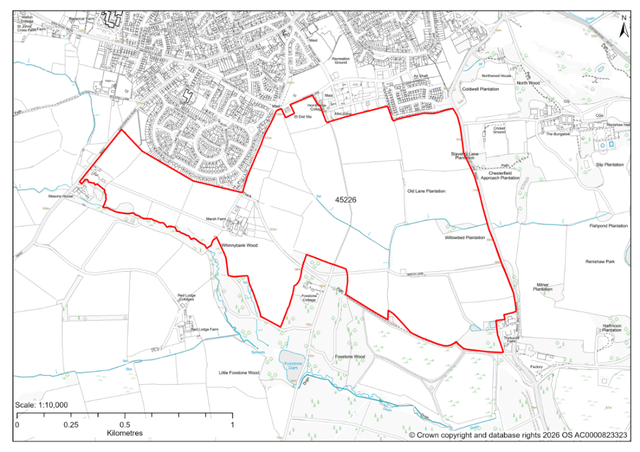

F. Potential development at Holmewood

- It is noted that there are 10 potential sites and 2 sites under construction at Holmewood, close to the border with Bolsover District (listed below and shown in brown in the image below), which together total 1,458 dwellings.

- These are (in descending order of size) –

- Land to the west of Feld Lane – 670 dwellings
- Windy Ridge, Tibshelf Road – 192 dwellings remaining
- Land to the west of Slack Lane – 150 dwellings
- Land to the side and rear of Goodacres, Tibshelf Road – 130 dwellings
- Land behind 289 to 339 Williamthorpe Road – 100 dwellings
- Land on the West side of Chesterfield Road – 63 dwellings remaining
- Land East of Central Street – 60 dwellings
- Land south of 205 Chesterfield Road, Holmewood – 50 dwellings
- Holmewood Miners Welfare – 17 dwellings
- Garage site, Shakespeare Street – 13 dwellings
- Car park at Hunloke Road – 7 dwellings
- Land at Hunloke Road – 6 dwellings

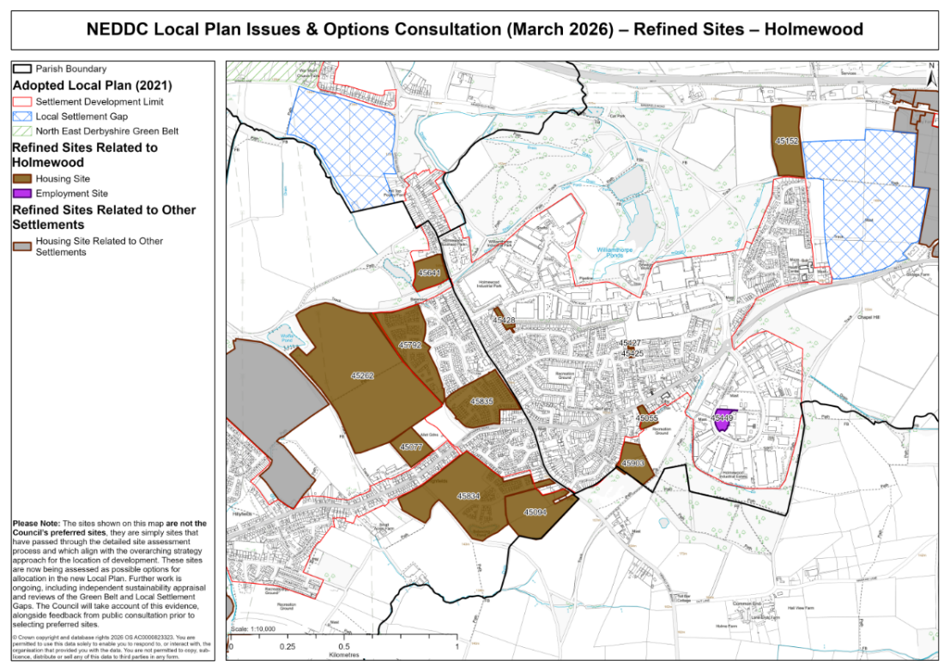

- Bolsover District Council has concerns about the potential cumulative impacts on the nearest motorway junction, M1 J29, and the local highway network, and potential heritage impacts, such as upon the setting of the Hardwick Hall complex of buildings.

Conclusion

- Bolsover District Council notes that NEDDC remain at an early stage in their plan-making process and that as a result a number of important evidence base documents are not yet available and that NEDDC are yet to outline their preferred options for growth in their new Local Plan.

- Therefore, at this stage Bolsover District Council remains supportive of NEDDC planning to meet its own residential and employment land needs.

- However, Bolsover District Council is concerned about the potential for growth close to the District’s boundaries and potential impacts on infrastructure located in Bolsover District.

- Going forward, the District Council would welcome the opportunity to examine the developing evidence base that will underpin the selection of preferred growth options and we remain committed to our long-standing joint working arrangements.

